**Understanding the role of global food trade on the transmission dynamics of antibiotic-resistant foodborne bacteria**

Alex L.K Morgan1, Mark E.J Woolhouse2, and Bram A.D van Bunnik2

1Centre for Immunity, Infection & Evolution and School of Biological Sciences, University of Edinburgh, Edinburgh, United Kingdom

2Usher Institute, University of Edinburgh, Edinburgh, United Kingdom

**ABSTRACT**

**INTRODUCTION**

1. Resistance is a big issue – specifically the resistance that might occur from livestock.
2. This is part of this one health issue – with studies often exploring the impact of transmission from livestock
3. However transmission from livestock is a multifaceted issue – transmission can come in the form of direct contact with domestic livestock, food products from domestic sources, but also from imported sources
4. Note some studies which have done this – the Ludden et al study as an example – which sampled food products from local supermarkets which obviously have food products from imported sources
5. But also mentioned that this often is not done – there needs to be more of an emphasis to explore the heterogeneity in terms of AMR transmission from livestock populations – to stratify the livestock population into both imported and domestic
6. This is important considering the implications of having heterogeneity in terms of transmission pressure – for example – give examples of other mathematical models showing that heterogeneity in terms of transmission pressure
7. This is therefore also the case in terms of AMR in a one health context – many reviews have stated that to understand AMR mechanistically from a modelling POV – we need to understand how the different sources of AMR might also contribute to AMR transmission
8. One such example is understanding how import of AMR on food products from different sources may also impact AMR transmission to humans – especially from livestock
9. This is an important aspect to consider considering a slow increase in food products over the next few years – the increase in the population requiring food to be imported
10. A likely reliance on imported food – and Brexit signing deals with countries with less than stellar food safety records
11. Means it makes sense to explore the impact of imported food products on the overall dynamics
12. We seek to explore the effect of heterogeneity in transmission pressure from livestock populations through the use of a compartmental metapopulation type model where we try to understand the impact of stratifying livestock antibiotic usage
13. We try to understand the impact on the impact of interventions such as the effect of curtailing livestock antibiotic usage when there is an import fraction.

**METHODS**

1. Model Structures (two plots one for simple and one for the complex model)

A compartmental model was developed to describe the transmission of antibiotic-resistant and antibiotic-sensitive foodborne bacteria from both domestic and imported livestock food products to human populations (Figure 1). Each host population can be stratified based on their respective infection status: susceptible humans (SH), humans infected with antibiotic-sensitive bacteria (ISH), humans infected with antibiotic-resistant bacteria (IRH), susceptible livestock food-animals (SA), livestock food-animals infected with antibiotic-sensitive bacteria (ISA) and livestock food-animals infected with antibiotic-resistant bacteria (IRA).

A constant transmission pressure was also added, defined as the

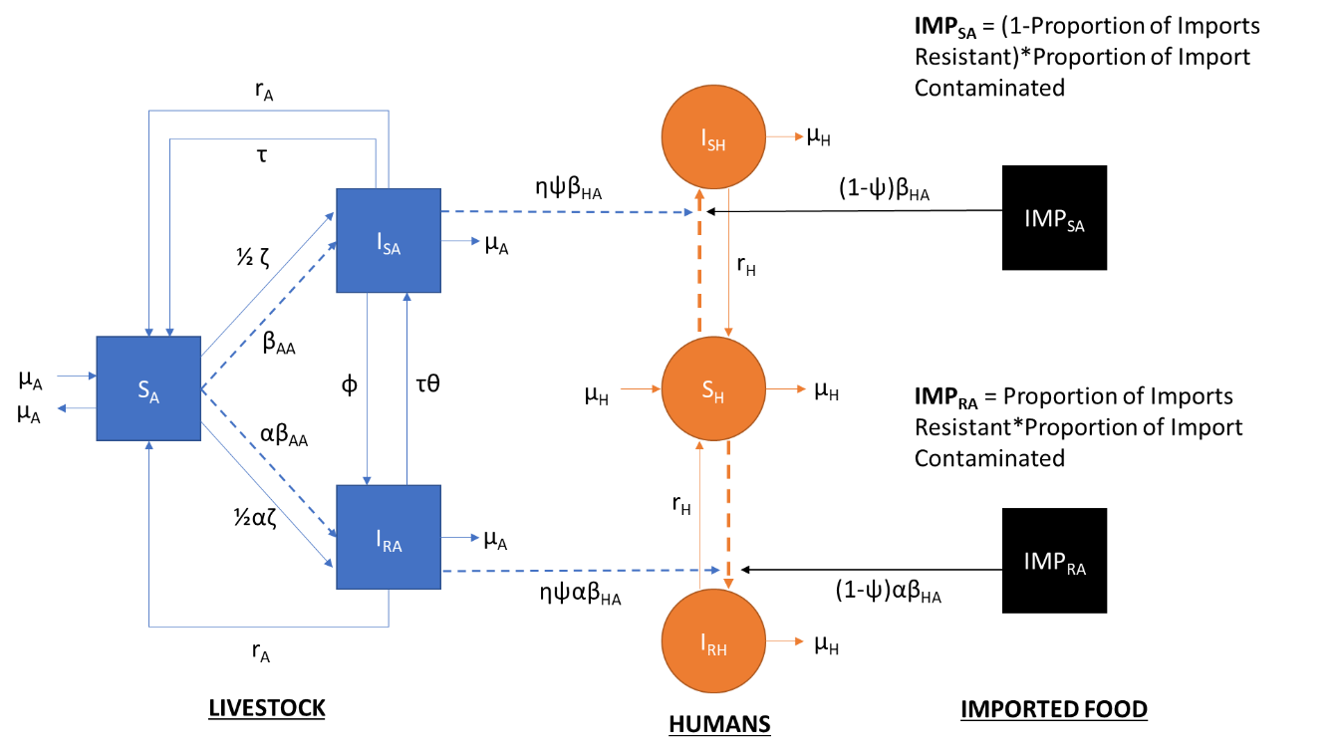

Figure 1.

A more comp



Figure 2. Equivalent model structure for complex model

**Need a more complex Model structure aswell**

1. Model outcome measures - (we have 3) – but with a focus on the efficacy of curtailment on resistance

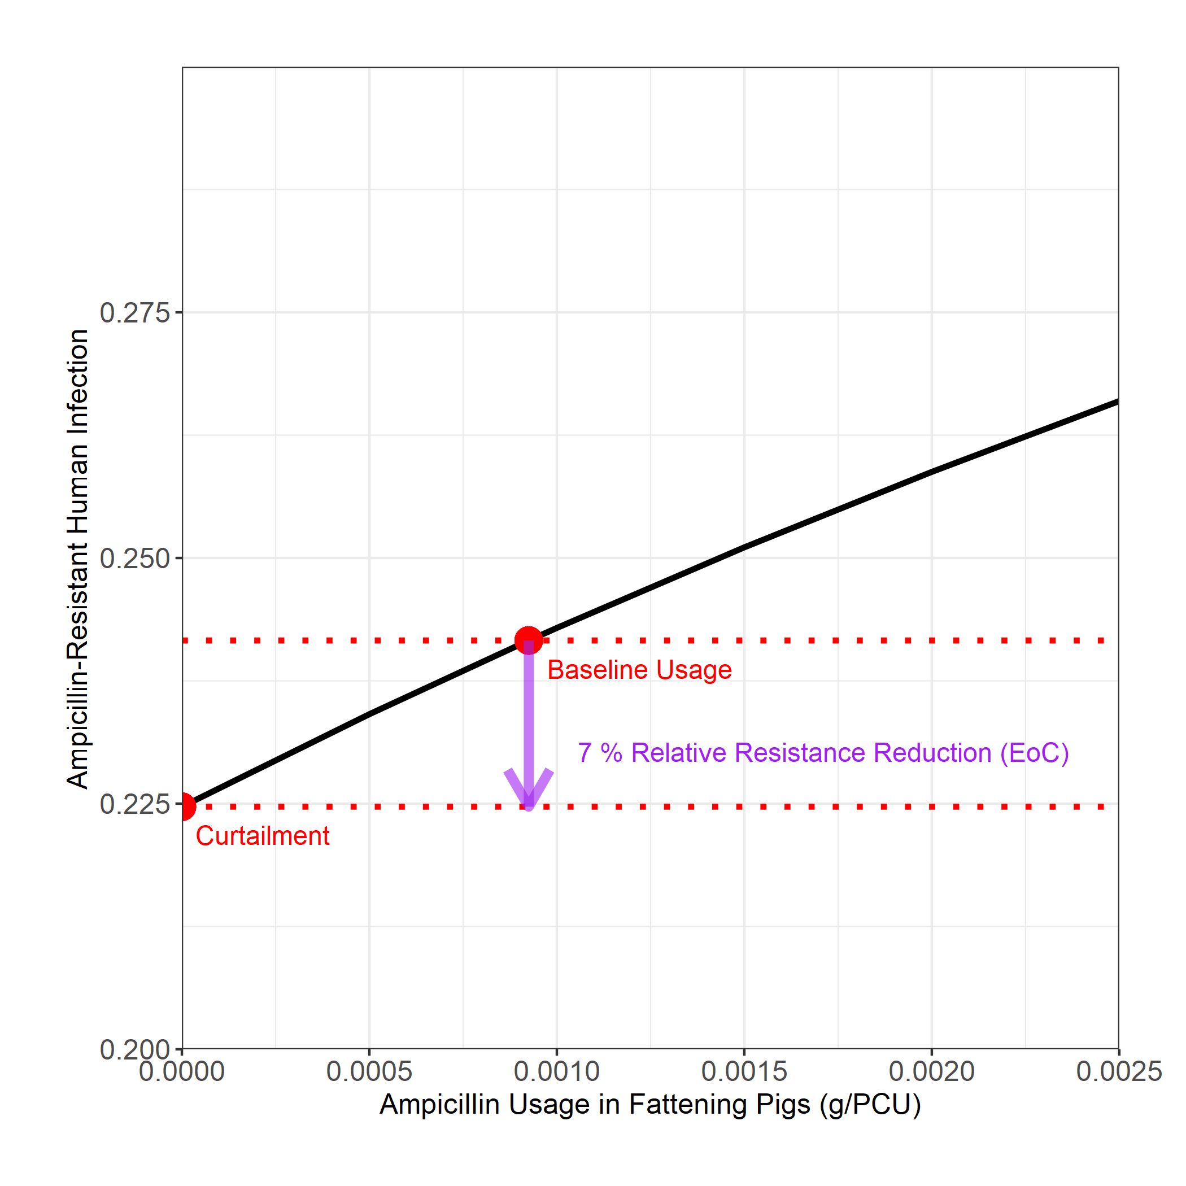

Figure 3.

1. Data
   1. Separate the data into three chunks
      1. General fitting dataset – to fit the relationship between usage and resistance
         1. What data we used from the ECDC to fit the model – specifically talk about how we tweaked the antibiotic usage data and how we only chose countries with >10 data points and how we used the data (multiple years) the way we did
      2. Import Dataset – used to specifically parameterise the import fraction
         1. We use this data to determine the share of the UKs food from UK and imported food supplies and to parameterise resistance and contamination from each of these countries
            1. (if we actually end up using the three case studies – this point we can use a table to show the import fractions).
         2. Need to explain how the import fractions were tweaked from the original one on the government website using other data (and also why we only took import data for 2018 – because historical data from previous years are not available).
         3. Need to explain what data we used to parameterise the importing countries – specifically the type of contamination data (carcasses) and the type of resistance data – specifically chosen to match each other
            1. With the contamination data there is a lot of nuance – converting from FBOp to competent authorities – using scaling calculations etc.
            2. How we only chose countries with 400cm^2 swabs – to keep it fairly uniform.
      3. UK dataset
         1. Need to describe that we need to parameterise quite a bit of UK data, livestock contamination, livestock resistance, human FBD, human resistance – as we are using a UK datasource
         2. Need to describe how we selected the data we did for the UK dataset
         3. Specifically the removal of certain datapoints because they were unrealistic (where it was just 45/45 resistant), the fact that we used 3 years worth of data (2015, 2016, 2017, 2018) – although one of these intermediate years aren’t available
         4. The eta parameter and how we use that one study ([Abattoir-based study of Salmonella prevalence in pigs at slaughter in Great Britain | Epidemiology & Infection | Cambridge Core](https://www.cambridge.org/core/journals/epidemiology-and-infection/article/abattoirbased-study-of-salmonella-prevalence-in-pigs-at-slaughter-in-great-britain/3FDEA88F8CF084908FC34C7A6A57052E)) – to model a static reduction from prevalence in the caecum of pigs to level of contamination found on swabs
2. Bayesian model fitting – how all this ties into the data
   1. What parameters we are fitting
   2. What distance measures are we hoping to use
   3. Choice of priors
   4. Specific details of ABC-SMC you can probably just leave to the referencing the Toni et al, paper
   5. How many generations we are running for, threshold values and distance measures etc
3. How and what senstivity analyses did we conduct
   1. Essentially mentioned the details of the LHS-PRCC and the need for monotonicity plots
   2. Mention that we conducted an eFAST analysis etc.
4. How we sampled from the different distributions

**RESULTS**

**Section 1**

**Result 1 – Basic model output of withdrawing antibiotic usage and the model fit**

* Supplementary material show the effect of psi on the model output
* Supplementary analysis - General sensitivity analysis plots – mention here – also mention that we do monotonicity plots – mention that we do an LHS PRCC and a eFAST analysis with the general model fit.
* Diagnostics for the all four of the
* What the model fit looks like without import.

We plotted the model fit for the ampicillin-resistant salmonella in fattening pigs case study. We identified a X fold increase in the incidence of human salmonellosis (baseline and curtailed incidence). We also note a X fold decrease the proportion of the ampicillin-resistant human salmonellosis when livestock antibiotic usage is curtailed. We note that the average level of contamination and resistance in imported food products was parameterised as higher (what it is for imports) than the fitted domestic level of contamination (prevalence x eta) and resistance (what it is for domestic). We note that increasing the decreasing the level of UK food products ffrom domestic sources in line with the UK pig supply, results in an overall X-fold increase in foodborne disease compared to the baseline scenario (**SUPPLEMENTARY**).

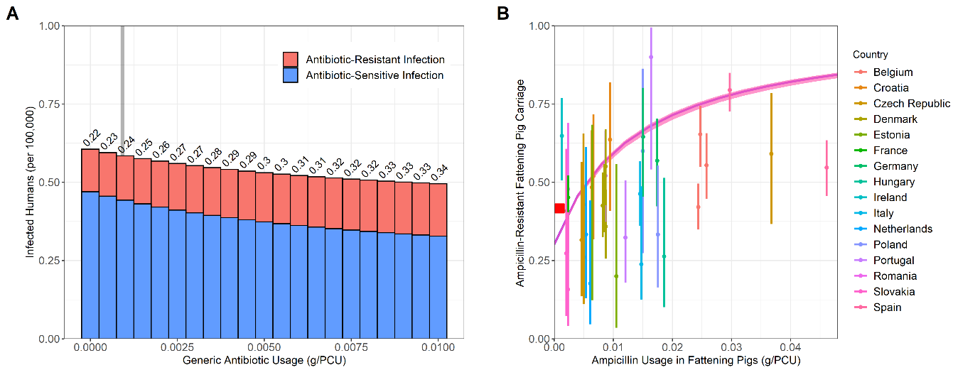

Figure 4. A) **Impact of alterations in livestock antibiotic usage (τ) on the daily incidence of salmonellosis and the proportion of resistant human infection (I*RHProp). B) Observed and estimated relationship between livestock antibiotic usage data and antimicrobial-resistant salmonellosis in humans.** Solid red lines and ribbons represent model fit resulting from the approximated posterior distribution using ABC-SMC and the corresponding 95% HDI. Country-specific 95% confidence intervals for the observed data (dots) were calculated for each case study using a 1-sample proportion test with continuity correction.

A general sesntivity analysis using LHS-PRCC and eFAST identified the proportion of contaimated imports resistant and the transmission related antibiotic resistance fitness cost as the most important parameters for determing the overall proportion of human resistance. The animal-to-human transmission rate from contaminated carcasses, the proportion of iimports contaminated and the proportion of UK food supply from domestic sources were important for determining the incidence of human salmonellsosis (**SUPPLEMENTARY**). Approximated marginal posterior probability distributions for the fitted model parameters from the ABC-SMC approach and the respective diagnostics can be found in the supplementary material (**SUPPLEMENTARY**).

**Result 3 – effect of altering the ratio of FBD and resistance on the results**

* We have two heatmaps the change in the main outcome measure – but also the change in the other outcome measure – the change in the amount of foodborne disease
* We then have some supplementary material showing the fbd and resistance for the pig case study/

We next identified the effect of import parameters in an uncertainty (or scenario) analysis; the proportion of imported food products contaminated (FracIMP) and the proportion of contaminated imported food products (PropResImp) on the outcome measure on the relative change in human resistance upon the curtailment of domestic livestock antibiotic usage (Efficacy of curtailment – EoC). The parameters were limited to fracimp ϵ [0, 0.3] and propresImp ϵ [0, 1], these values were chosen due to the ranges observed in ECDC datasets (**SUPPLEMENTARY**). The uncertainty analysis also included alterations to the proportion of UK food from doomestiuc sources with baseline and alterantive aprameterisation with psi = 0.454, the proportion of UK food when spercifcially looking at pig imports. We also explored the effect of changing the decrease in proportion from prevalence to contamination in domestic livestock (eta)m exploring a range from baseline, 0.05 (greater clearance) and 0.2 (worst clearance).

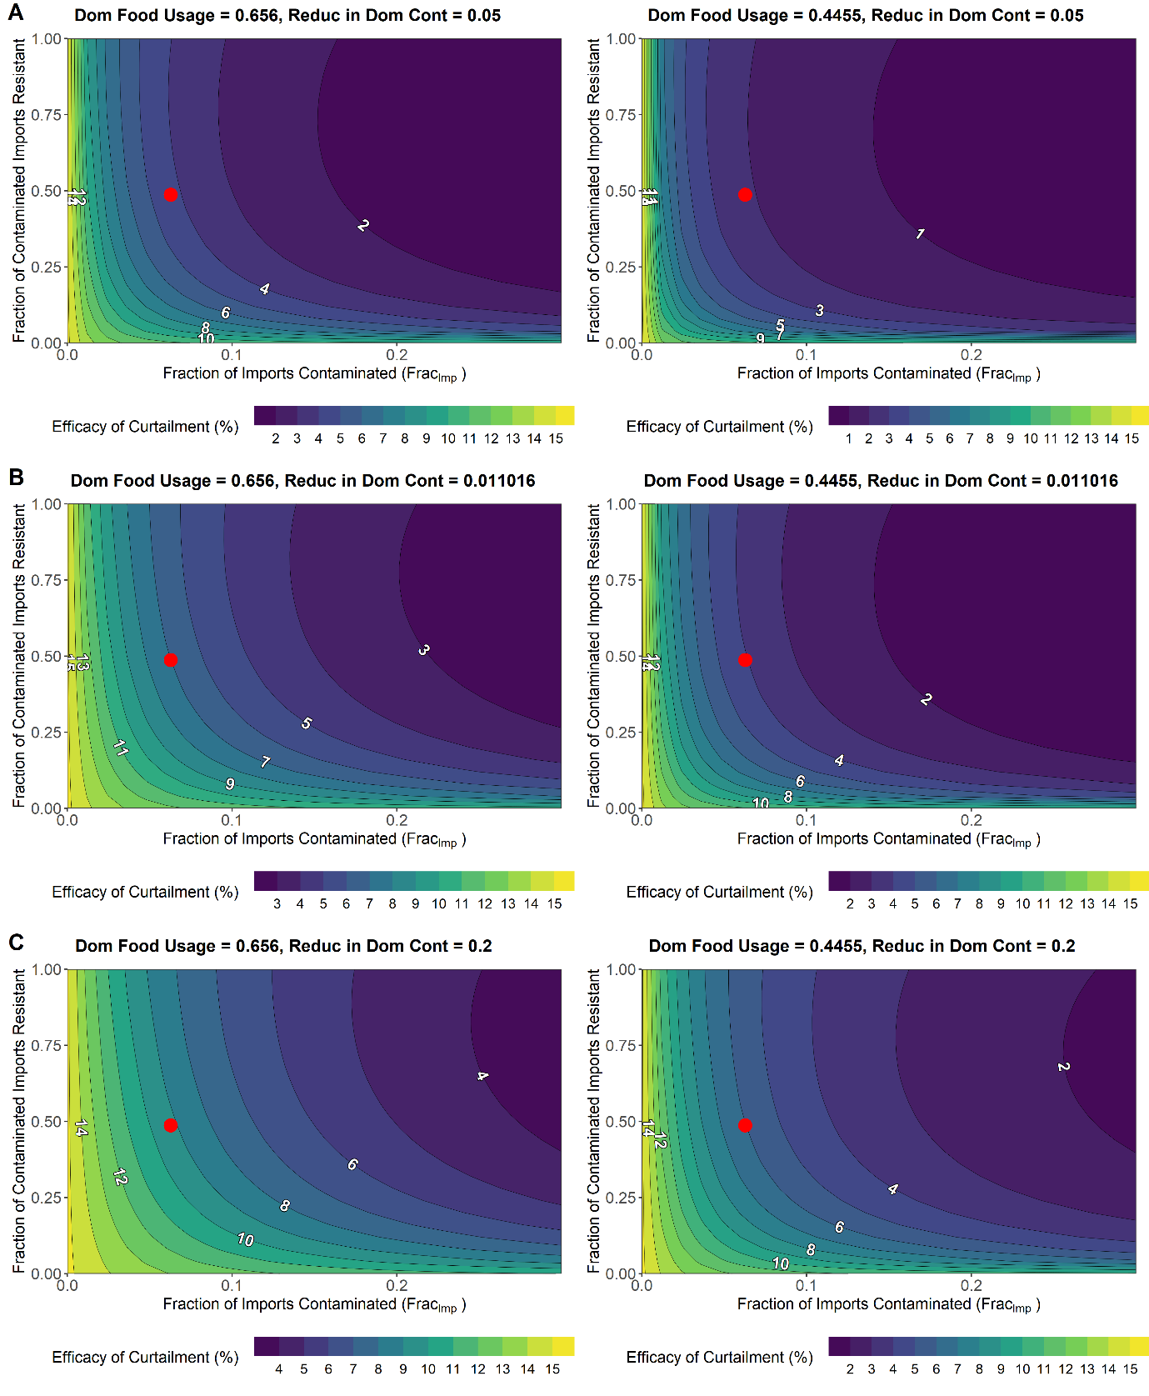

**Figure 5. Impact of altering fracimp and propresimp on the efficacy of curtailment for two psi case studies. A) Eta values of 0.05 (better clearance of pathogens). B) Eta values of 0.011 (Baseline). C) Eta values of 0.2 (worse clearance).**

We note that in all analysis increasing the level of contamination and resistance in imported food products has the effect of decreasing the Efgficacy of curtailing, making local interventions less capable of reducing human resistance. Decreases to fracimp and propresimp have the opposite effect, with increases in the efficacy of curtailment (EoC). A related phenomneom can also be observed with decreases to psi with the psi = 0.4455 case study, with equivalence reduictions to fracimp and propresimp resulting in greater reductions to the Efficacy of Curtailment (EoC). Reductions to the eta parameter – resulting a greater level of prevalence being reduced when being transformed to contamination also expands on this phenomenm, wth reductions to fracimp and propresimp, resulting in greater reductions to the efficacy of curtailment (Figure 6A), with the opposite beingf observed when eta is increased to 0.2 (Figure 6C).

This suggests that changes which increase the influence of import on human resistance (increasing contamination (frac imp inceease), imported food usage (psi decrease) and increasing resistance (propres imp decrease), decreasing local contamination (eta increase)) – results in a worse efficacy of curtailment.

* This can likely be attributed to a sort of saturation effect, with the level of attributable resistance from domestic sources decreasing – therefore local interventions will have less of an effect and EoC will decrease

Result 4 – sensitivity analyses LHS-PRCC and eFAST – general case study only

* Supplementary material monotonicity plots

A LHS-PRCC and eFAST sensitivity analysis was next conducted to assess the importance of model parameters on the efficacy of curtailment – with a particular focus on import parameters. We note that the proportion of UK food products from domestic sources () is an important parameter for increasing the efficacy of curtailment (crrelation coef = ) and with the fraction of imports contaminated decreasing the efficacy of curtailment (correlation coeff), under half of the contribution of these parameters () to the variation in the outcome measure can be attributed to second-roder effects including interactions with other parameters.

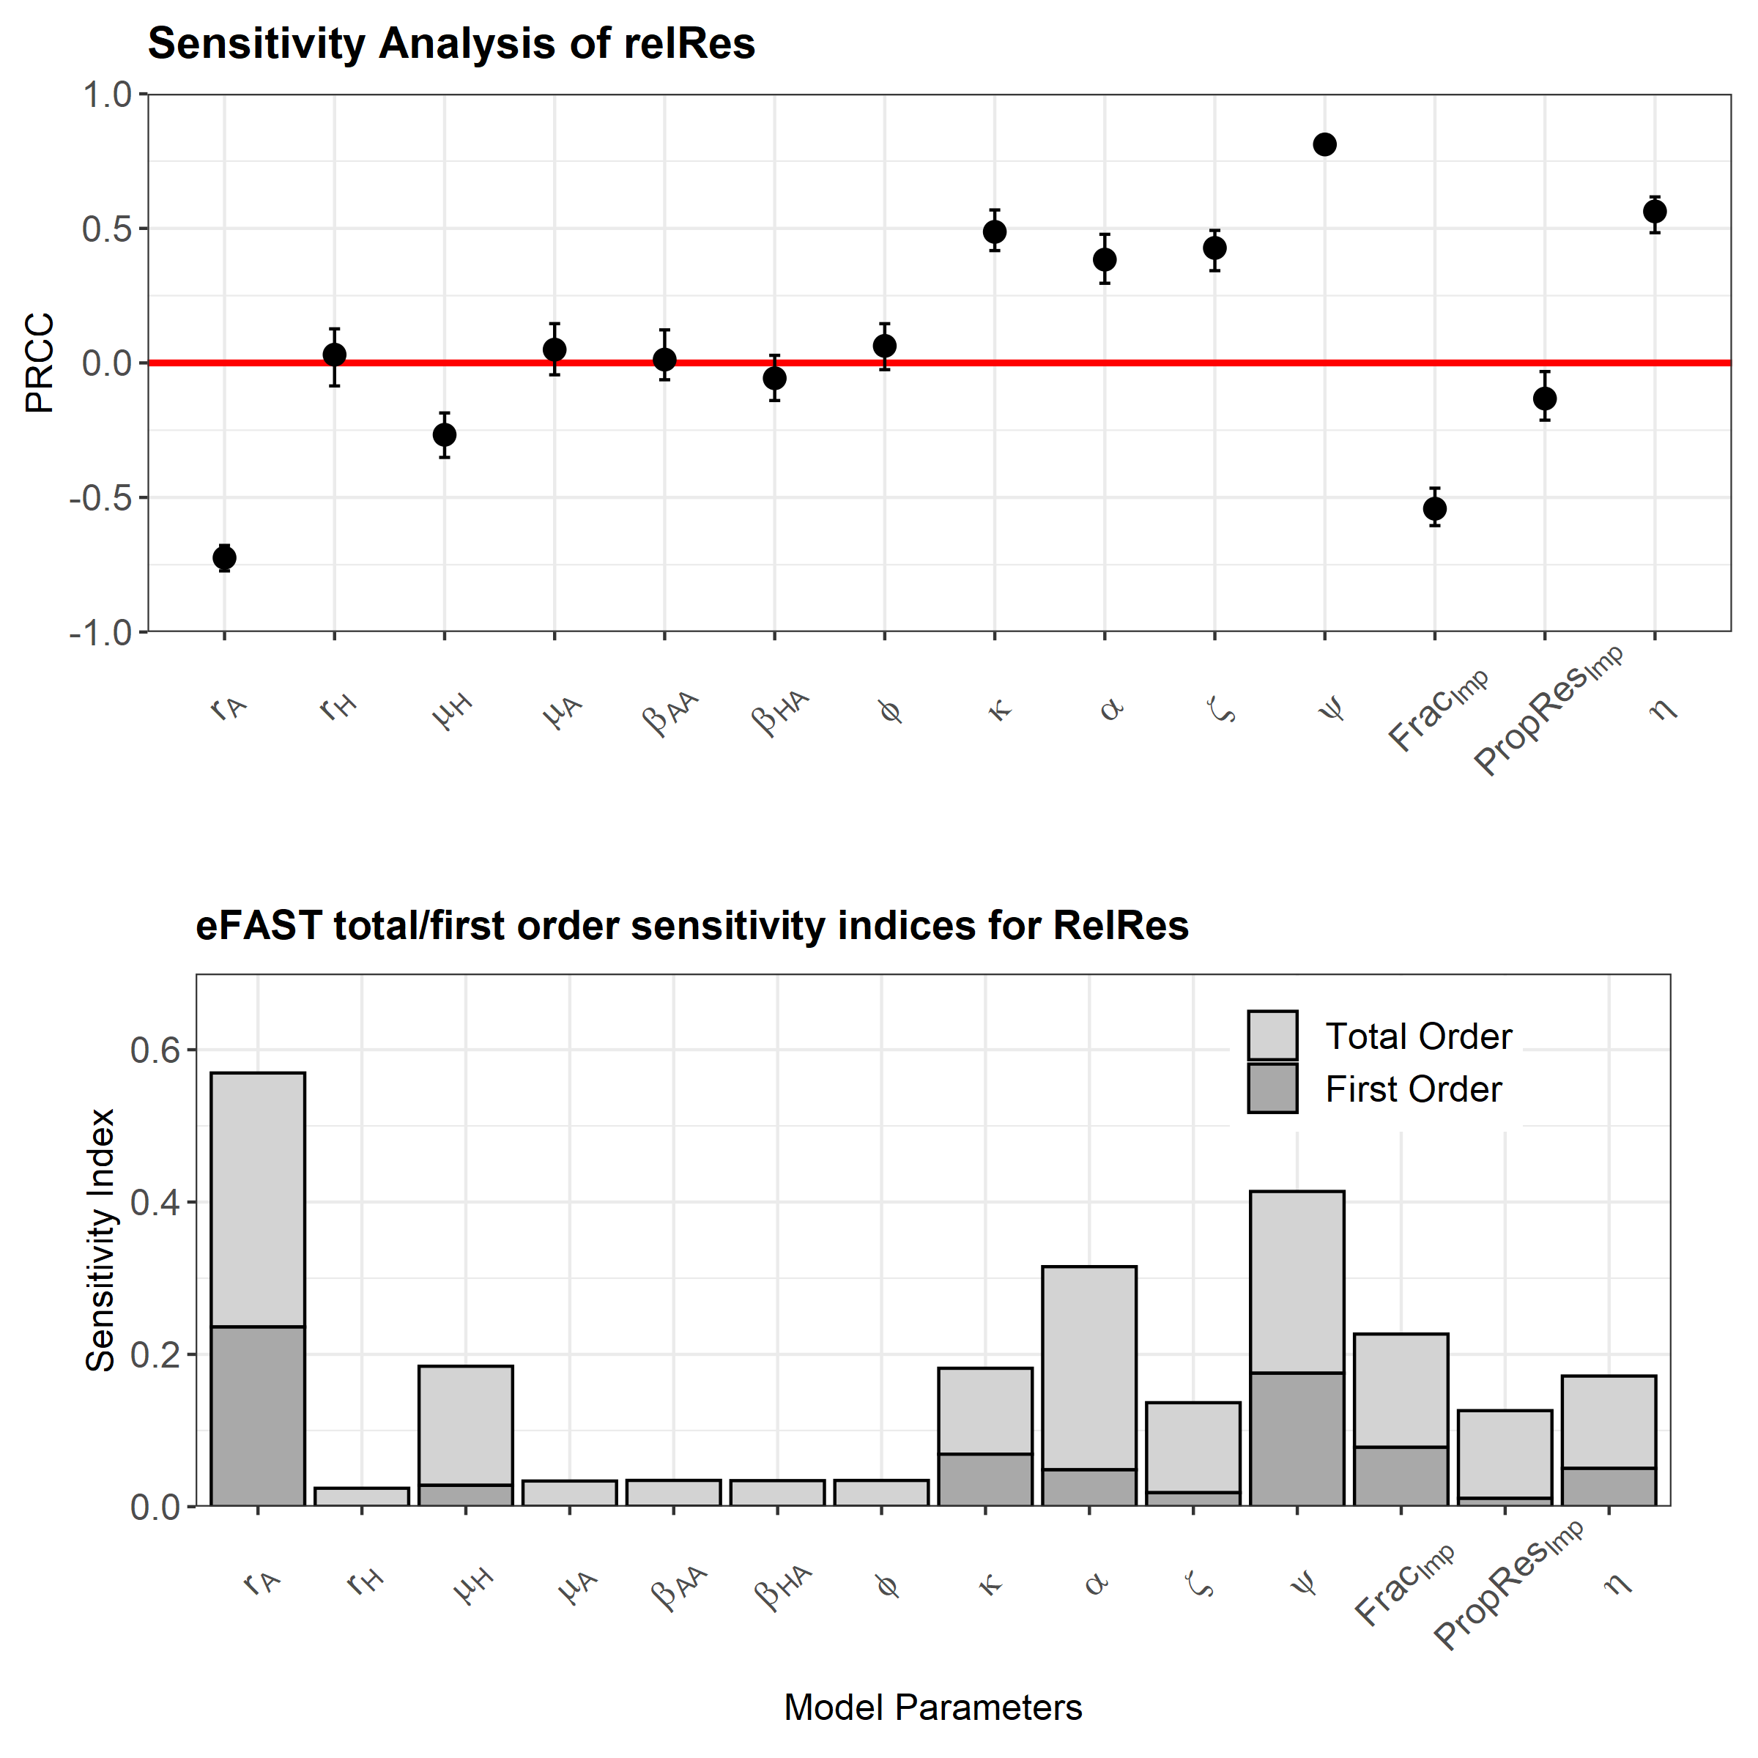

**Figure 6. Sensitivity analyses for the efficacy of curtailment (EoC) outcome measure. A) Latin hypercube sampling partial rank correlation coefficient test (LHS-PRCC). B) Extended Fourier amplitude sensitivity test (eFAST).** Note that 95% confidence intervals for each correlation coefficient was generated through generating n = 100 bootstrap replicates.

Interestingly the rate of livestock recovery from carriage had a strong effect on reducing the efficacy of curtailment when increased. The proportion of contaminated food products resistant to ampicillin was also found to be important in reducing the efficacy of curtailment. While increasing the proportionate reduction in prevalence to contamination () and therefore increasing the level of contamination on domestic food products, has the effect of increasing the efficacy of curtailment

**Section 2**

To assess the impact of import heterogeneity on the model results we fitted an adapted version of the model with stratified level of importation to the model parameterisation data. The key feature of this model includes a stratification of the homogenous importation transmission pressure into 10 distinct importing countries, FRA, NED, xxx, each with distinct levels of parameterisation required for the level of contamination and resistance on imported food products.

This increased heterogeneity allows for model outcome measures such as the incidence of salmonellosis to attributed to different countries. We note an X-fold increase in the incidence of foodborne disease and a X-fold decrease in human resistance. Approximated marginal posterior probability distributions for the fitted model parameters from the ABC-SMC approach and the respective diagnostics can be found in the supplementary material (**SUPPLEMENTARY**).

Result 6 - Basic Model Output of the effect of withdrawing antibiotic usage on levels of attributable resistance

* Need to alter this figure to have 3 figures here – one for either the unnormalized or the normalised level of resistance (maybe unnormalized levels of resistance would make more sense).
* Supplementary analysis – the effect of changing the level of usage for the levels of resistance

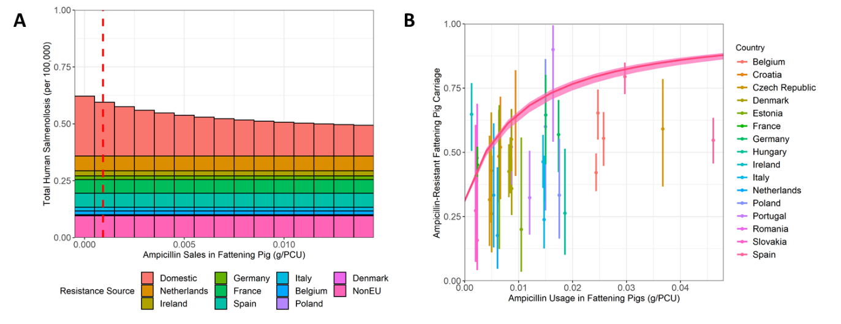

Figure 7. A) **Impact of alterations in livestock antibiotic usage (τ) on the daily incidence of salmonellosis and the proportion of resistant human infection (I*RHProp). B) Observed and estimated relationship between livestock antibiotic usage data and antimicrobial-resistant salmonellosis in humans.** Solid red lines and ribbons represent model fit resulting from the approximated posterior distribution using ABC-SMC and the corresponding 95% HDI. Country-specific 95% confidence intervals for the observed data (dots) were calculated for each case study using a 1-sample proportion test with continuity correction.

Under baseline model fitting and antibiotic usage – the model predicts that the majority of foodborne disease and resistance are from domestic sources (fbd – 50% and res – 50%), decreasing to lower levels (fbd – 50% and res – 50%) when antibiotic usage is curtailed. As expected the level of attributable fbd and resistance from imported sources do not change when domestic livestock antibiotic usage is curtailed.

Result 6

We next explored the effect of altering the level of UK domestic food supply from domestic sources (psi) on the efficacy of curtailment outcome measure. The relationship between psi and the efficacy of curtailment can be characterised by two areas on the plot, an area where changes to domestic food usage have a greater than proportionate change on the efficacy of curtailment – suggesting that increasing import may more negatively affect the efficacy of curtailment, and an area where changes to domestic food usage has a lower than proportionate change on the efficacy of curtailment.

Figure 8.

We note that the baseline efficacy of curtailment was modelled at 7%, suggesting a relative reduction in resistance from baseline to total curtailment. The baseline relationship between the proportion of UK food products from domestic sources and the efficacy of curtailment sits in this “greater than proportionate” change in the efficacy of curtailment outcome measure – this means that…

To explore the effect of changing the average characteristics of import across importing countries, we explored the effect of changing the average level of import contamiantion , resistance across all importing coutries. We also explored the effect of ranging the extent of reductions to domestic livestock salmonella carraige prevalence on the relationship between the proportion of UK food from domestic sources (ψ) and the efficacy of curtailment (EoC). The average level of contamination was ranged from fracImp ϵ [0, 0.3], in accordance with the range of values observed in ECDC reports.

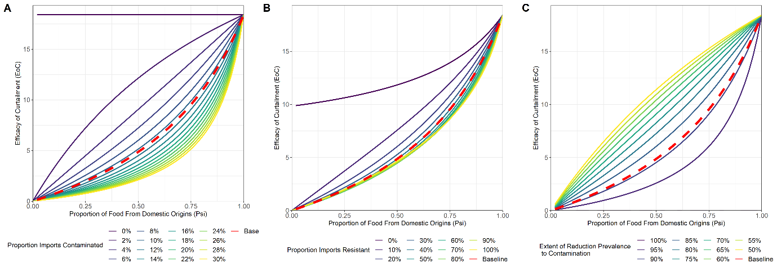

Figure 9.

Decreases in the overall contamination of imported food products to low levels – 0-2%, had the effect of shifting the relationship between the proportion of UK food products from domestic sources and the efficacy of curtailment, to the “green” area where the increase in importation (psi < 0.656) leads to a less than proportionate decrease in the efficacy of curtailment. The opposite phenomenom was observed with increases in the overall level of contamination. Interestingly a “saturation” type effect was also observed, with increases in the average level of contamination above the baseline relationship quickly reaching a similar level to the maximum explored values of contamination.

Changes to the average level of resistance had a similar effect where reductions to the average level of resistance to below 10% shifted the relationship the proportion of UK food products from domestic origins and the efficacy of curtailment to an area where it has a less than proportionate effect on the efficacy of curtailment. Interestingly decreases in the efficacy of the reduction in prevalence to contamination on domestic food products has the effect of shifting the relationship to the area where increases in import have a less than proportionate effect on the efficacy of curtailment.

We next aimed to explore the effect of heterogeneity in the relative contribution across importing countries (ShareImp) on the overall level of import on the efficacy of curtailment. The relative share of import across importing countries were sampled 1000 from two beta distributions, with parameters Beta(alpha = 1, beta = 1) and Beta(alpha = 0.5, beta = 2). These represent two hypotheses about importation – either importing uniformly across different countries in the UKs trade network or importing the vast majority of imported food products from a few select countries. It is important to note that all other parameters are kept to baseline levels when ShareImp. The average effect and the minimum/maximum efficacy of curtailment was identified for each value of theproportion of UK food from domestic sources

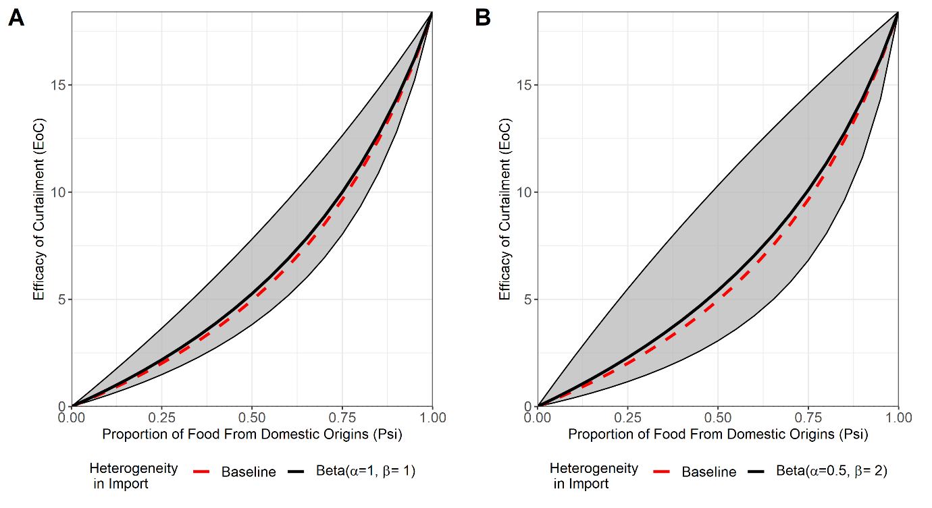

Figure 10.

Sampling from either distribution did not drastically change the baseline relationship between UK food supply from domestic sources and the efficacy of curtailment when observing the average effect. However, we note that a more heterogenous distribution of importing countries will result in a greater level of uncertainty with regards to the effect of the intervention compared to a more unfirom distrinutiom of importing countries.

**DISCUSSION**